Setting up MFA – Step-by-step guide for Outlook web verification to call your phone

Setting up MFA to call your phone for verification

Log in to outlook.office.com as usual to access your email via the web:

Enter your username:
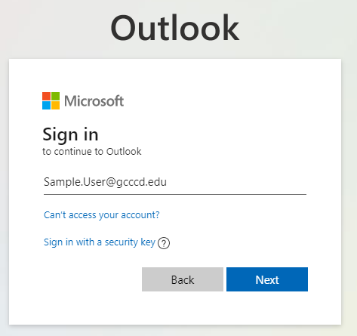

Enter your password:
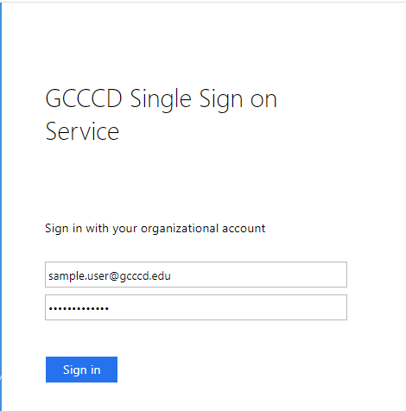

If you get the prompt to stay signed in you can click on “Yes” and check the box “Don’t show this again” if this is your regular computer. If you are signing in from a computer you do not normally use, select ‘No”.

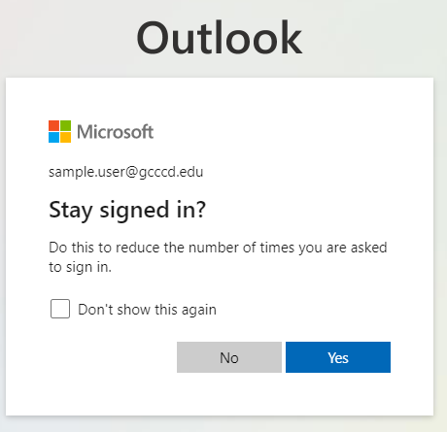

In order to set up MFA, you will get this message asking for more information. Click Next:

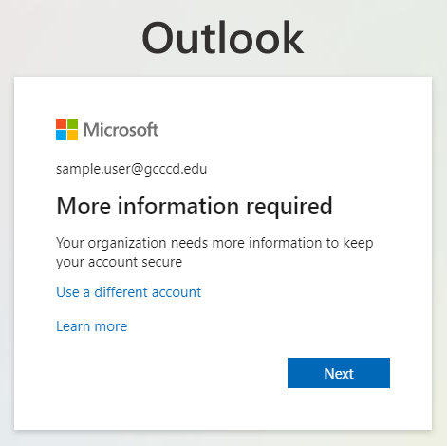

Here you will need to enter information to add your phone for multi-factor verification.
From the drop-down, select “Authentication phone”
Select the country code from the drop-down, then enter your phone number, including the area code
Select the Method “Call me” to receive a phone call
Click “Next” when done

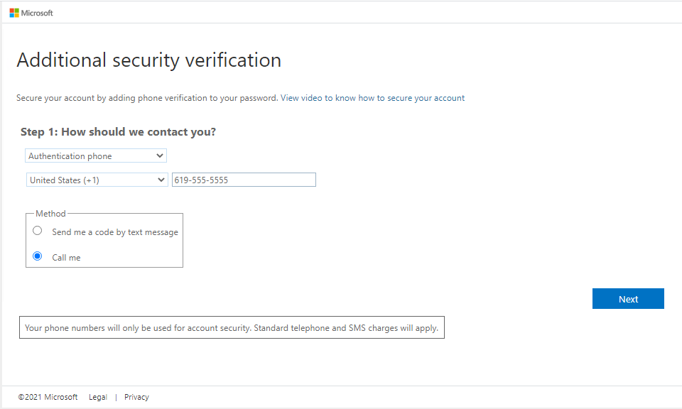

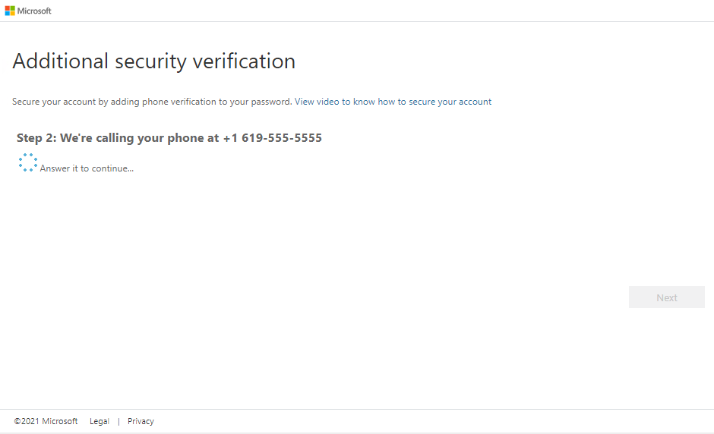

You will receive an automated phone call from Microsoft to the number you provided. To complete the verification process, answer the call and press the # key when prompted. That's all there is to it and the verification process is complete. You should now be signed in and see your email as you normally do.

