Setting up MFA – Step-by-step guide for Outlook web verification to send a text code

Setting up MFA to send a text message with a code to your phone for verification

Log in to outlook.office.com as usual to access your email via the web

Enter your username:
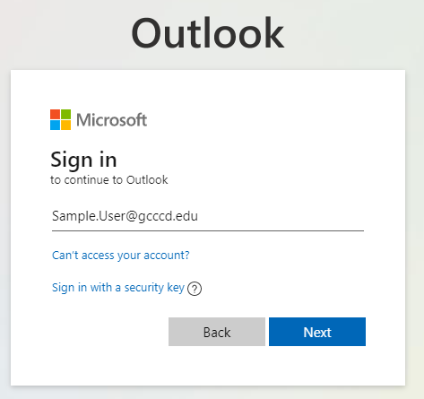

Enter your password:
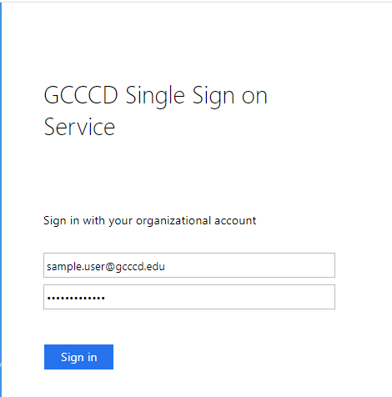

If you get the prompt to stay signed in you can click on “Yes” and check the box “Don’t show this again” if this is your regular computer. If you are signing in from a computer you do not normally use, select ‘No”.

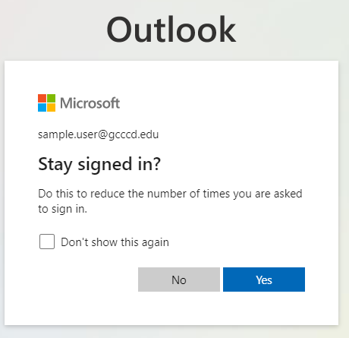

In order to set up MFA, you will get this message asking for more information. Click Next:

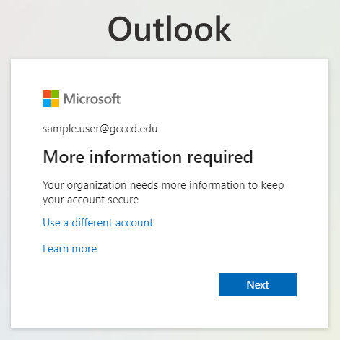

Here you will need to enter information to add your phone for multi-factor verification.
From the drop-down, select “Authentication phone”
Select the country code from the drop-down, then enter your phone number, including the area code
Select the Method “Send me a code by text message” to receive a code by text
Click “Next” when done

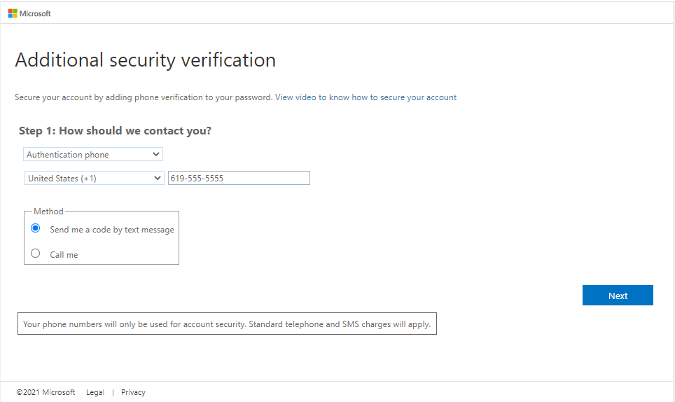

You will receive a code by text. Enter the numeric code on the screen for additional security information when prompted. 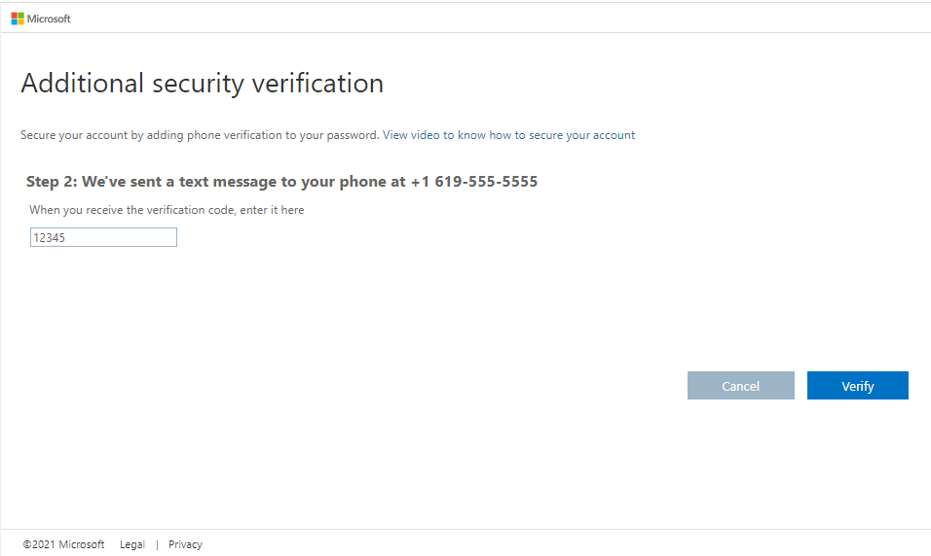

Click on the Verify button. If the code entered is successful, you will see a message that says "Verification successful!"
Click on the Done button.
That's all there is to it and the verification process is complete. You should now be signed in and see your email as you normally do.

